|  |  |
| --- | --- |
|  | JAYPEE UNIVERSIY OF ENGINEERING & TECHNOLOGY **TUTORIAL SHEET-1**  **COMMUNICATION SYSTEM (10B11EC514)** |



**Q 1**. Find the energies of the signals shown in **Fig. 1**. Comment on the effect on energy of sign change, time shifting or doubling of the signal. What is the effect on the energy if the signal is multiplied by ***k***?

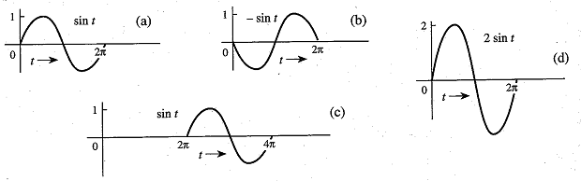

**Fig. 1**

**Q 2**. **(a)** Find $E_{x}$ and ${ E}_{y}$, the energies of the signals $x\left(t\right)$ and $y(t)$ shown in **Fig. 2a**. Sketch the signals $x\left(t\right)+y(t)$ and $x\left(t\right)-y(t)$ and show that the energies of either of these two signals are equal to $E_{x}+E_{y}$. Repeat the procedure for the signal pair of **Fig 2b.**

**(b)** Repeat the procedure for the signal pair of **Fig 2c**. Are the energies of the signals $x\left(t\right)+y(t)$ and $x\left(t\right)-y\left(t\right)$ identical in this case?

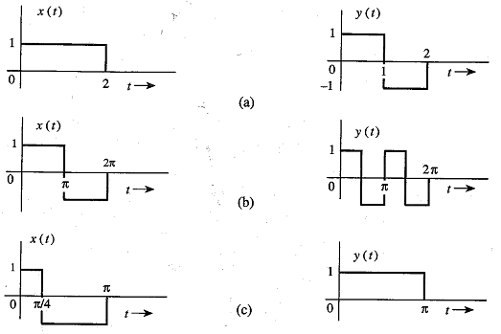

**Fig. 2**

**Q 3.** Determine the power and the rms value for each of the following signals:

1. $10 cos⁡(100t+\frac{π}{3})$**(d) $10\cos{5t\cos{10t}}$**
2. $10\cos\left(100t+\frac{π}{3}\right)+16 sin⁡(150t+\frac{π}{5})$**(e) $10\sin{5t\cos{10t}}$**
3. $\left(10+2 sin3t\right) cos10t$**(f) $e^{jwt}\cos{ω_{0}}t$**

Solution

**Q 1.**

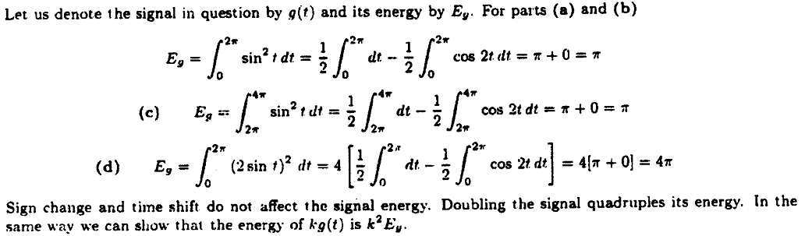

**Q 2.**

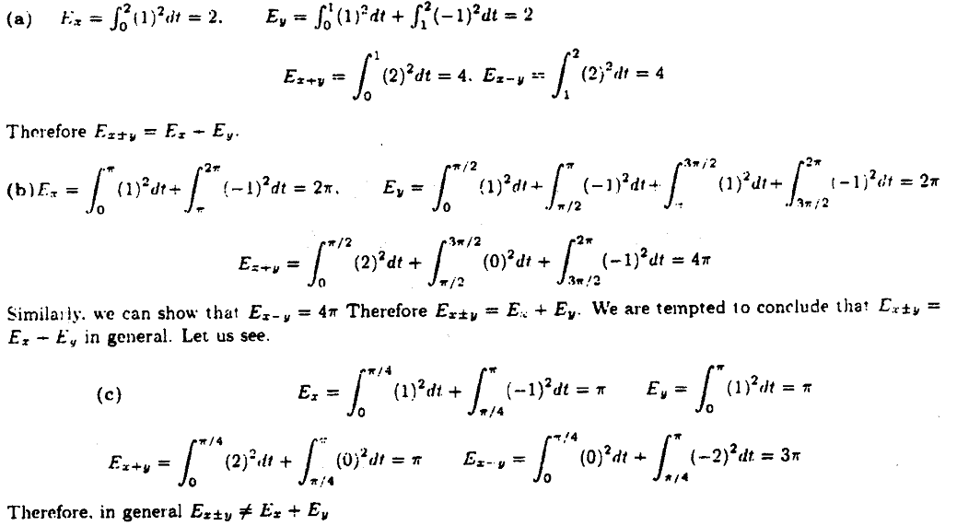

**Q 3.**

